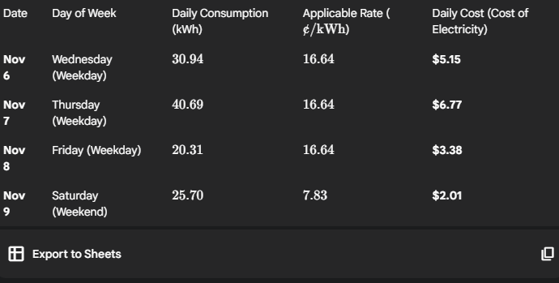
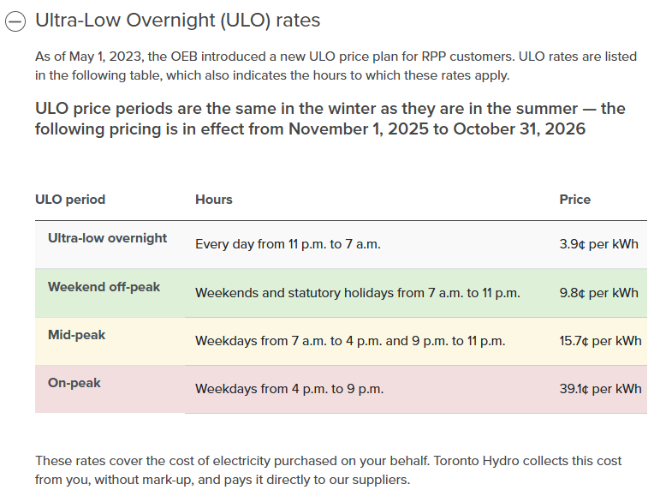
Nov 6 30.94 kwh
Nov 7 40.69 kwh
Nov 8 20.31 kwh
Nov 9 25.70 kwh

